Accessibility Issues

This document is here to show that I understand accessibility issues and have the ability to raise them.

In the interests of time I have only looked at the following page:

* <https://ensekautomationcandidatetest.azurewebsites.net/Energy/Buy>

# Page Is Missing Lang Attribute

This page needs a language to be specified in the html attribute.

e.g. <html lang="en">

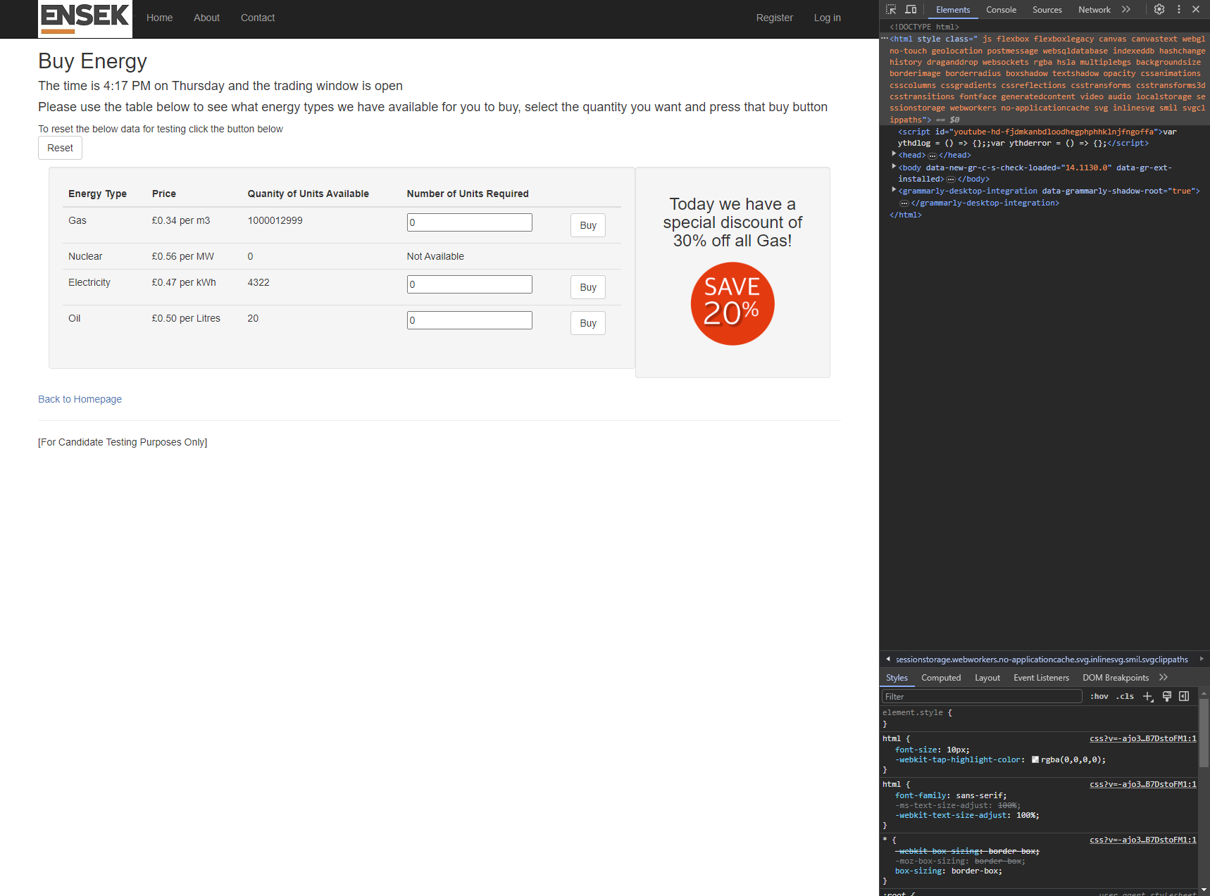

# Unit Fields Share The Same ID

The unit fields all share the same ID attribute. These must all be unique.

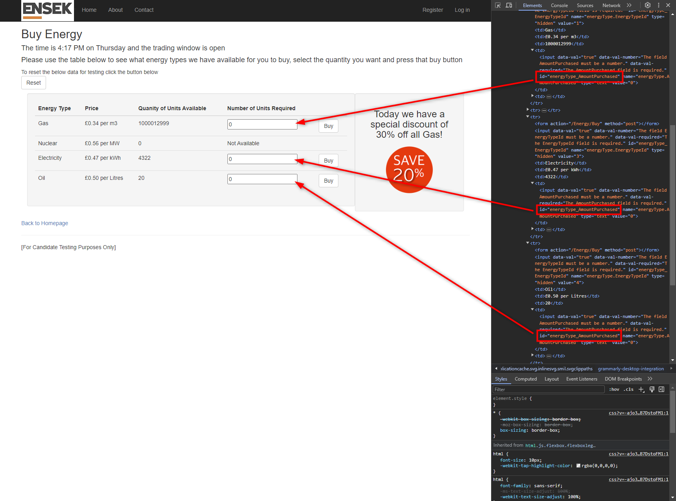

# Images are missing alternative image description

Users with screen readers will be unable to see the ENSEK logo and will be unable to see that there is a big right “Save 20%” on the page.

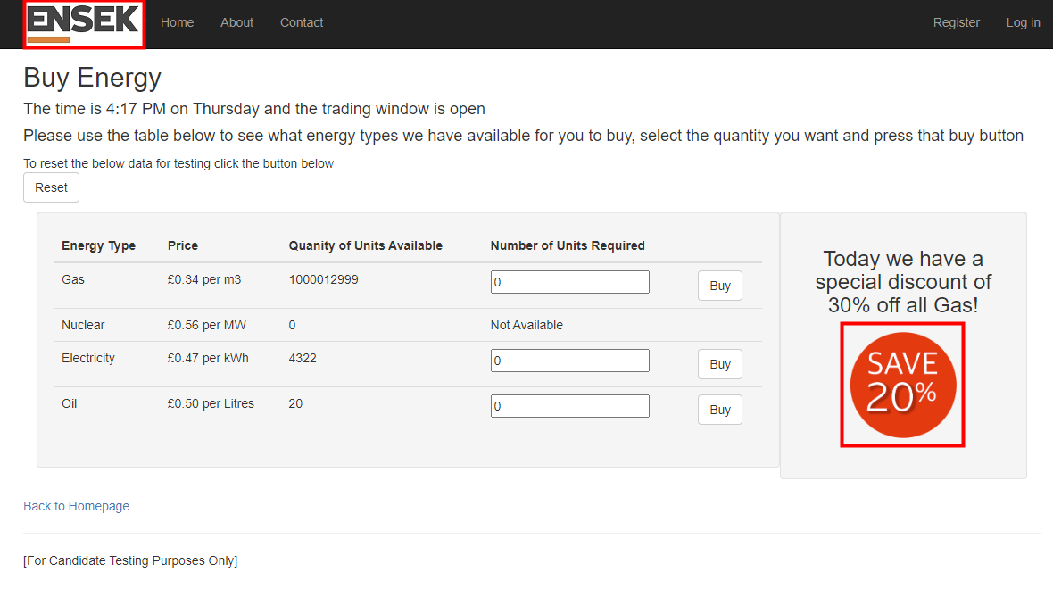

# Fields And Buttons Are Missing Alternative Text

It is unclear to me if customers with accessibility requirements will be able to determine which type of energy they are buying without ARIA labels on the different energy type unit fields and Buy buttons.

